**Practical 5**

**Install Samba to share folder or files between Windows and Linux.**

**Install the samba package**

sudo apt-get update

sudo apt-get install samba

**Create a directory for it to share**

mkdir /home/kali/sambashare/

**Created two files to test**

[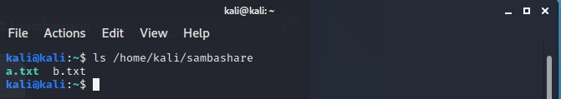](https://raw.githubusercontent.com/keane3pereira/LSA_Pracs/master/res/prac5/shared_dir.PNG)

**The configuration file. Have to add the directory we want to share.**

sudo nano /etc/samba/smb.conf

**Add this to the end of the file.**

[sambashare]

comment = Samba on Ubuntu

path = /home/username/sambashare

read only = no

browsable = yes

[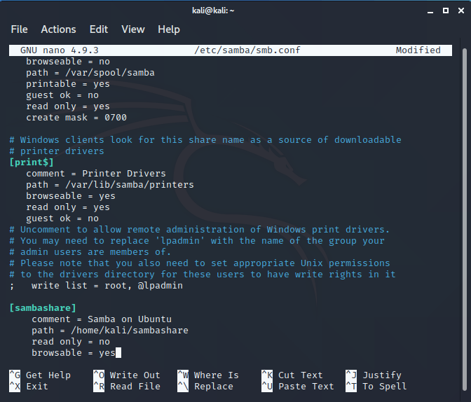](https://raw.githubusercontent.com/keane3pereira/LSA_Pracs/master/res/prac5/smb-conf.PNG)

**Start/Restart the service**

sudo service smbd restart

**Allow samba through the firewall**

sudo ufw allow samba

[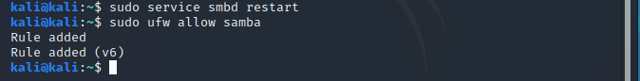](https://raw.githubusercontent.com/keane3pereira/LSA_Pracs/master/res/prac5/service-ufw.PNG)

**Setting up User Account**

sudo smbpasswd -a kali

***Note:****Username must belong to a system account.*

[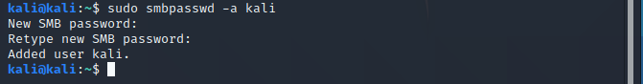](https://raw.githubusercontent.com/keane3pereira/LSA_Pracs/master/res/prac5/adduser.PNG)

**Open the file explorer, type smb://<ip-address>/<shared_file>**

smd://127.0.0.1/sambashare

[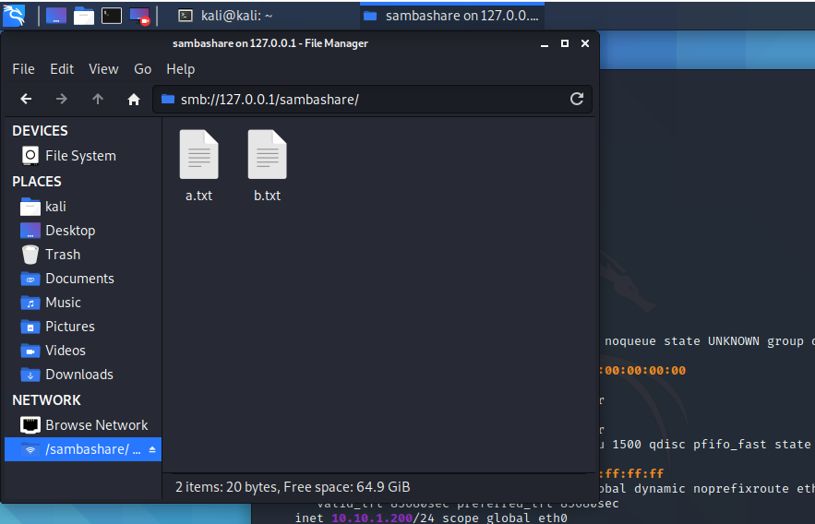](https://raw.githubusercontent.com/keane3pereira/LSA_Pracs/master/res/prac5/smb-dir.PNG)